Bugs

1. Error thrown not descriptive of what a user is missing when the user has forgotten username.

The format of email is wrong. The error message should inform the user.

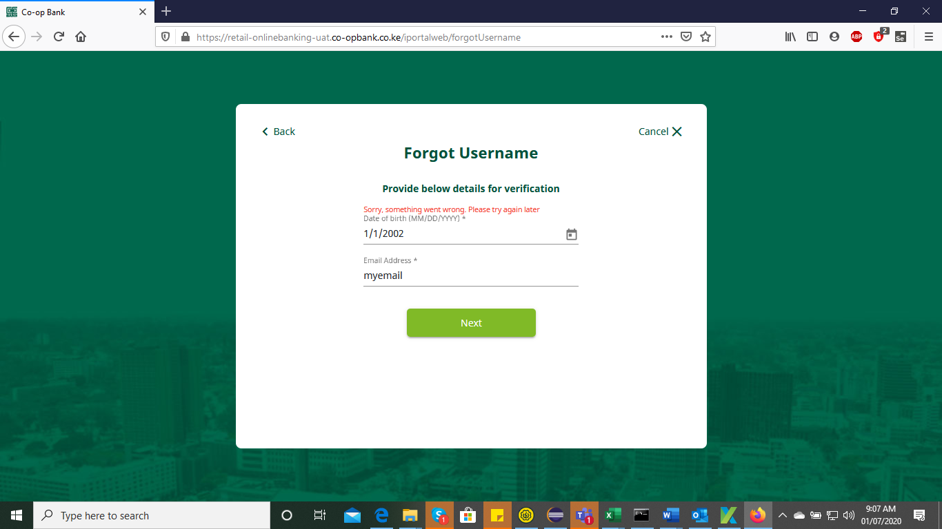

1. User can login with an incorrect/any password. Used 1
2. User can use any OTP. Used 11111
3. Invalid “**User Id/Password**” instead of Invalid “**Username/Password**”

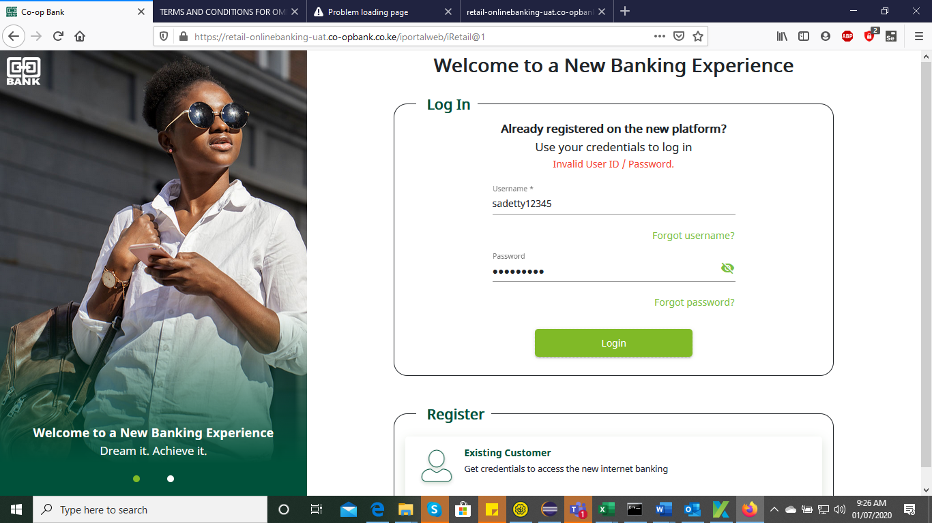

1. Registration – Phone number not labelled. It’s also not indicated as required by use of an asteric(*)

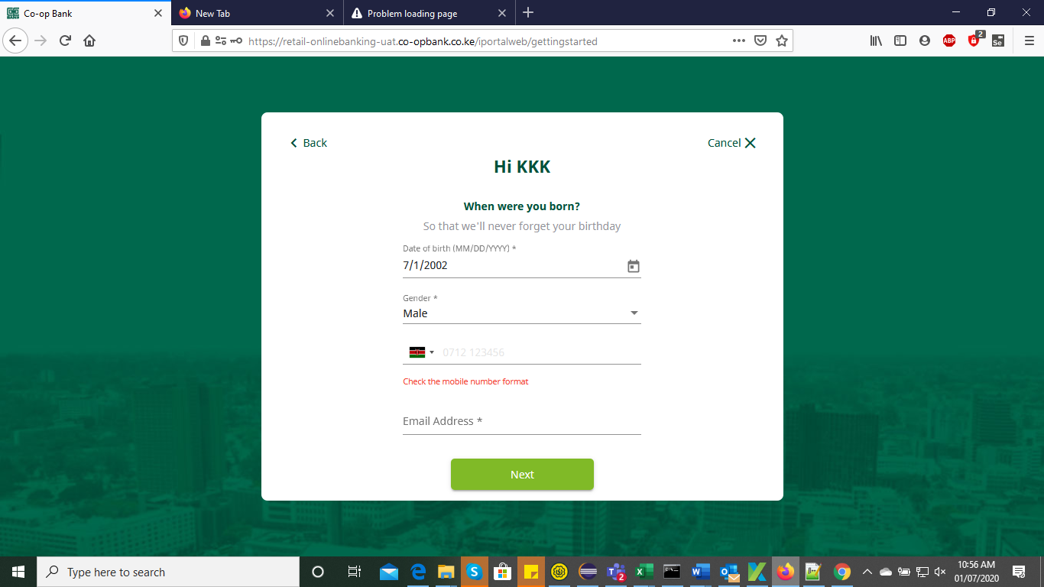

1. Registration – After filling the required fields I get an error “Sorry, something wrong happened …” there is no option to report this issue to support for assistance or an error message of what is wrong with the inputs provided.
2. 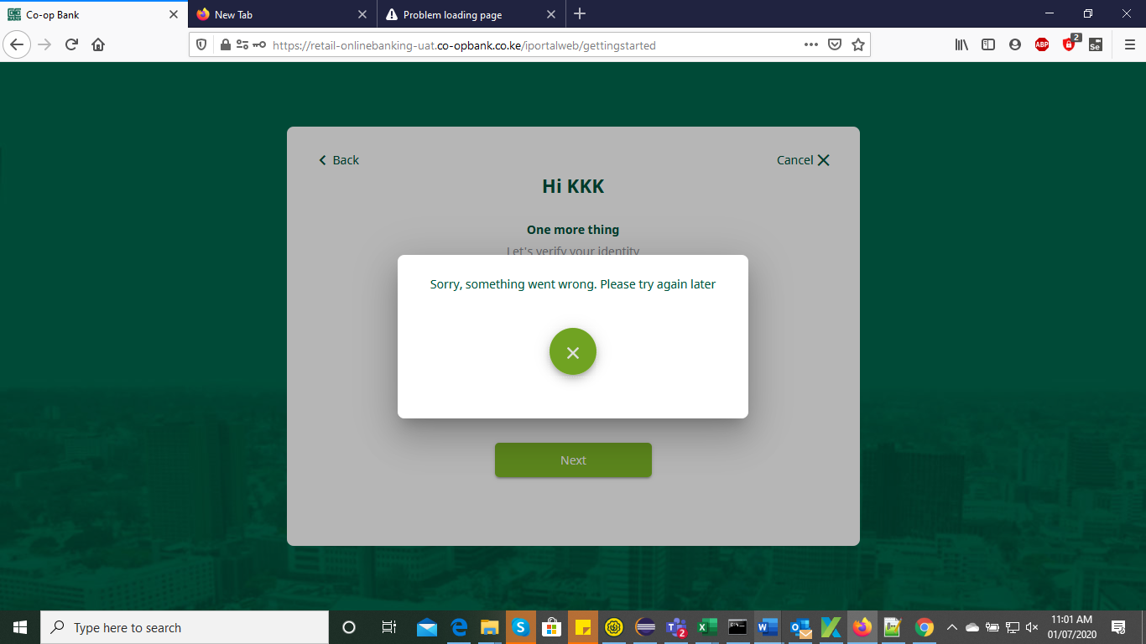
3. Frequently getting allow location access. After allowing for a session that setting should be valid for that session.

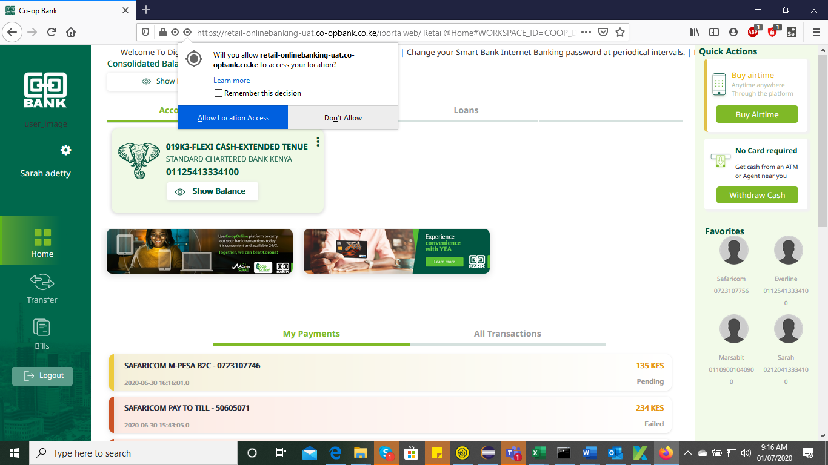

1. User’s last name starts with a lowercase. Shows **adetty** instead of **Adetty**
2. **Cancel** button not working on Manage OTP screen page
3. There is a disconnect on the UI icons on the dashboard.

Settings icon placed on the profile picture (After Uploading profile picture).

Edit pen icon changes to Settings edit after uploading profile pic.

1. Logout Placed on the Profile Management.

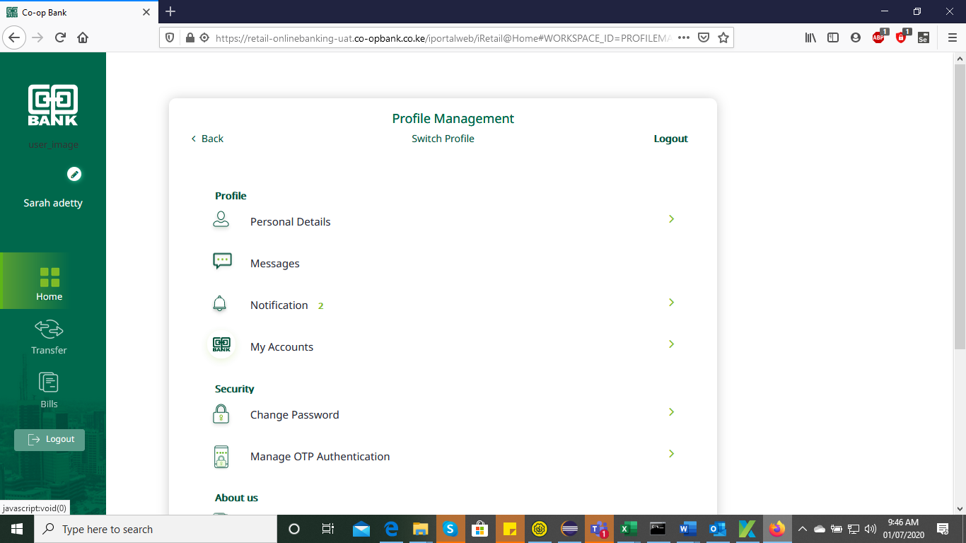

4. I keep on experiencing **Redefining your experience**. This happens intermittently. User must close the tab and login again for this to clear

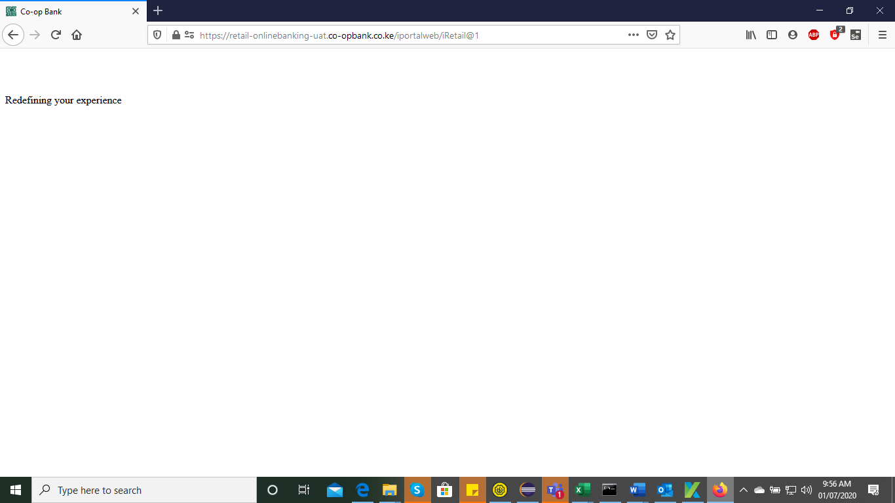

1. Some Icons are displayed on top of text.

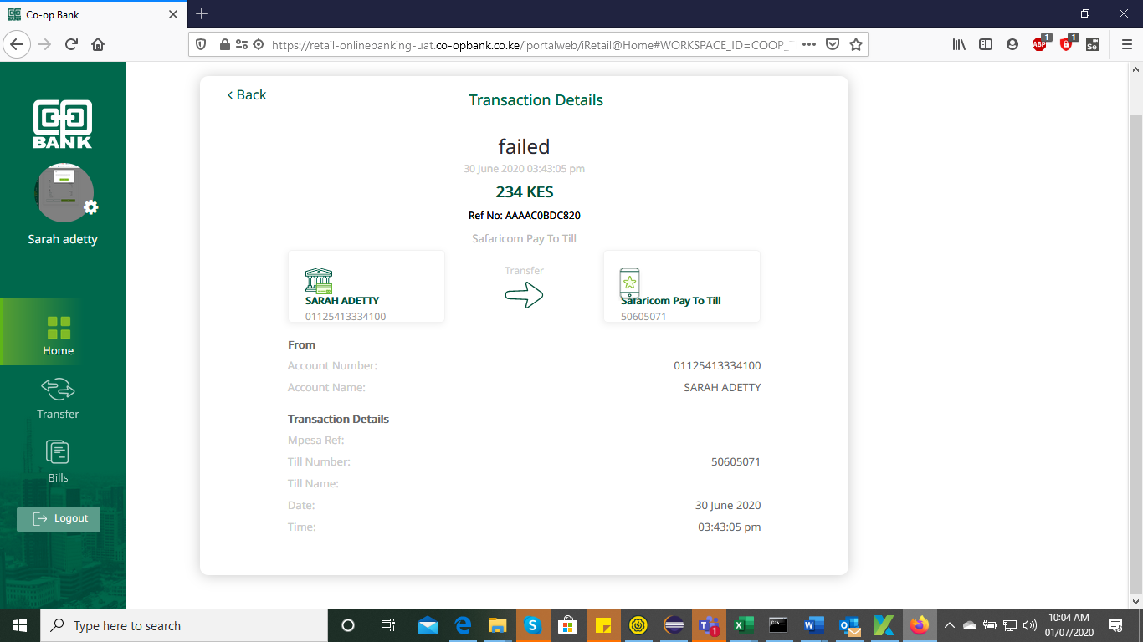

1. OTP input fields on the Manage Your account – Input text are outside the input field. Some are on the border.

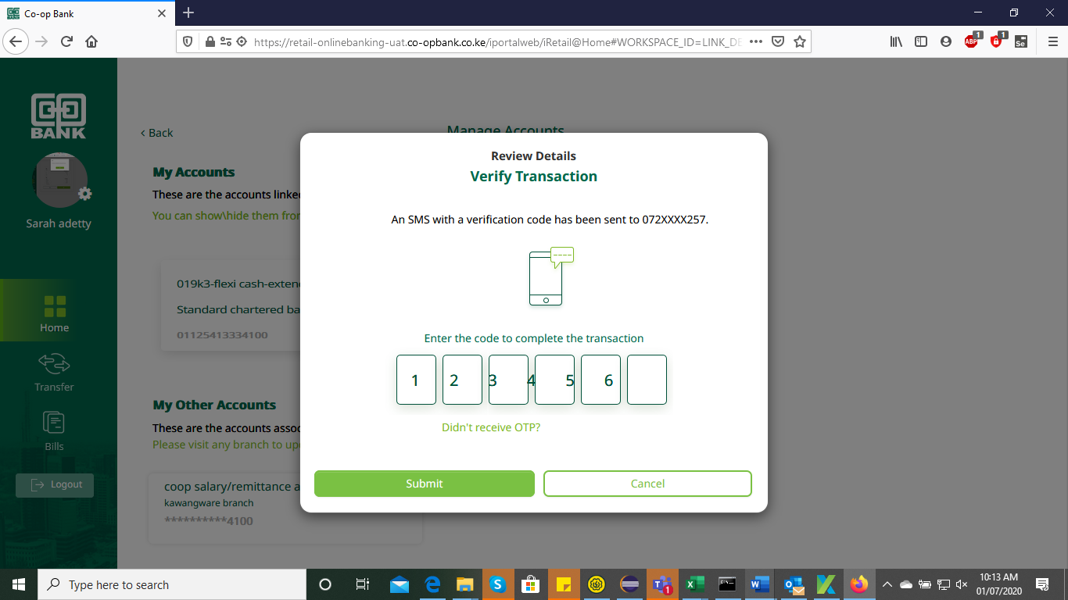

1. Home>Manage Your Account – Hide/Unhide account does not work. For example, standard chartered account 01125413334100 is still shown after hiding it.
2. Settings > User Profile – Highlighter shows user is on the “Home” when the user is at the settings dashboard.
3. Export not working

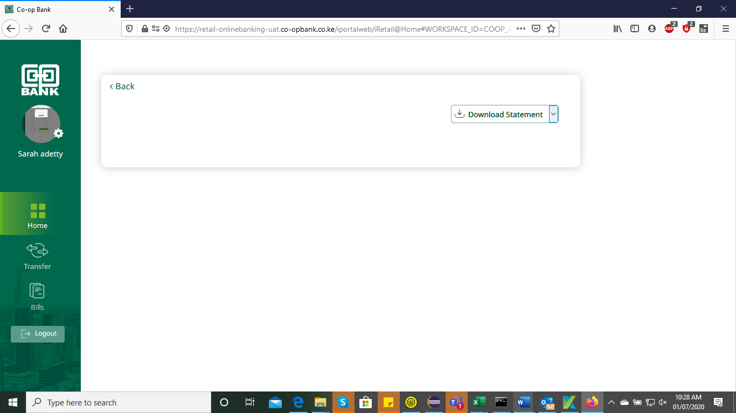

1. Home>Cards>Next Page angle bracket ( **>** )active even when there are no other records.

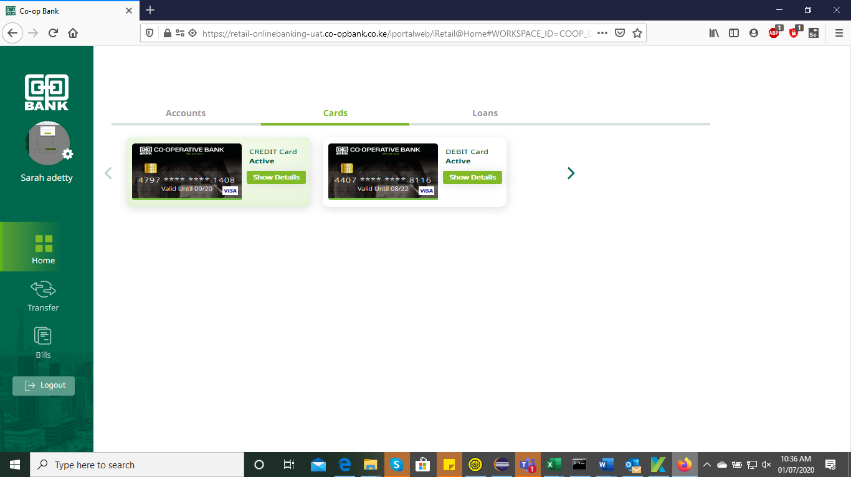

1. Payment – System Unavailable on clicking submit.

